BISHOP MACKARNESS AND THE CARTER CASE (1877-1880)

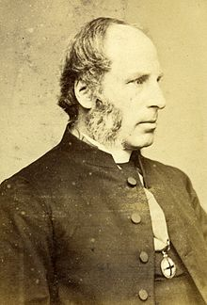

In the late 1870s, Bishop John Fielder Mackarness was involved in a high-profile Church controversy. Canon Thomas Thellusson Carter, Rector of Clewer, was considered by some parishioners to be unacceptably 'High Church' in his practices, and legal action was taken against him.
Some of the practices objected to were:
1. At Holy Communion he stood at the centre of the altar facing east instead of at the north end as prescribed by the Prayer Book
2. He mingled water with the wine in the chalice
3. He placed a cross on the altar
4. He had processions and choral Communion
But, it is recorded, “the first movement that made a commotion was lighting the candles at an early celebration.”
Source: www.standrewsclewer.org
(Canon Carter also set up the House of Mercy in Clewer 'for the rescue of fallen women', and, in 1852, the Sisterhood of the Community of John the Baptist, which again met with some disapproval.)
Proceedings were initiated against Carter, using first the Public Worship Regulation Act and then the Church Discipline Act. Bishop Mackarness withheld his consent in both cases. The complainants then went to the Queen's Bench for a Writ of Mandamus, which was initially granted. Bishop Mackarness appealed against the Queen's Bench ruling, and the decision was reversed by the Court of Appeal, with the House of Lords sustaining the reversal in 1880.
The various financial costs of the actions to Bishop Mackarness are recorded as totalling £322.14. This was later defrayed by a public appeal, organised by G W Corker, the Vicar of Stony Stratford.
Bishop Mackarness always stressed that he did not take these actions out of sympathy with Canon Carter's practices: 'My final determination was formed ... not out of any personal liking for ceremonial novelties - but in view of the importance of vindicating the true independence of the whole ecclesiastical jurisdiction, as handed down in England from the earliest times'.
Canon Carter resigned before the proceedings were over, maintaining that he had done this of his own free will, out of respect for the Bishop's views.

Note: The main source for this summary is Charles Coleridge Mackarness' 1892 book 'Memorials of the Episcopate of Bishop Mackarness' along with several letters, reviews and newspaper cuttings from that time.

*

